22 October 2023 Postcard

Lazy day in Florence. Nothing was scheduled for today! We had chosen to schedule our four-course included dinner in the hotel’s “lesser” restaurant for the evening, but that was it.

We both wanted to try the famous Florentine steak, so we had the desk make us a lunchtime reservation for today—the only remaining unscheduled meal—at a restaurant just across the street from the hotel.

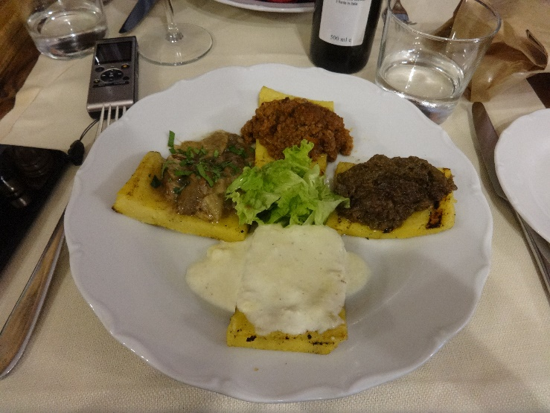I was up for breakfast as usual, though I was pleased not to have to hurry. Then I went back to my room and worked on the trip’s blog (transcribing notes, triaging photos). David warned me he was going to skip breakfast and sleep in, but he was upright and ready to go for lunch.

My starter was four slices of polenta, sautéed and topped with (clockwise from the top) a meat ragout, chicken liver pâté, cheese sauce, and porcini mushrooms. David had tomato-and-bread soup so thick he ate it with a fork.

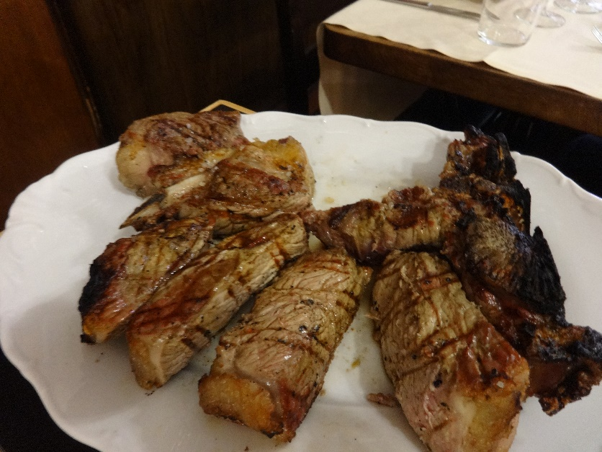

We then shared a huge T-bone, shown here with some segments already removed, and skipped dessert.

David wanted to get another look at Brunelleschi’s dome and at the famous baptistry doors, so we walked over there after lunch.

The baptistry doors are magnificent, though the ones we saw are replicas. The originals are in the cathedral’s museum. I couldn’t get a close up of every panel (some were 10 feet over my head), but the detail on the ones I got was stunning.

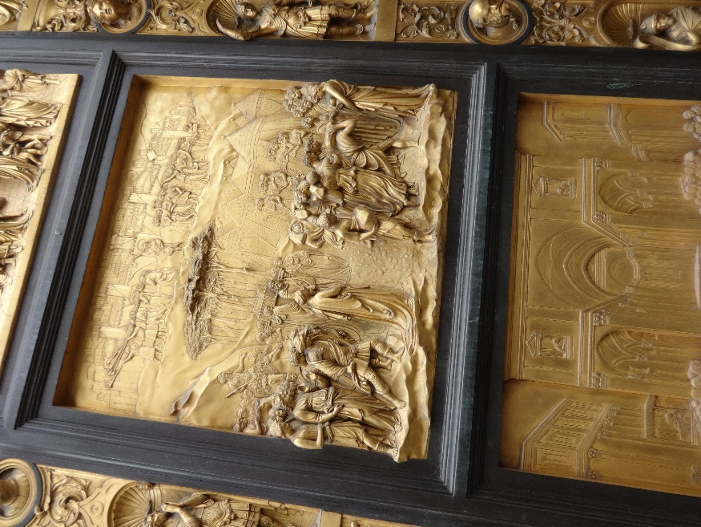Then it was back to the hotel so David could go back to bed. I considered going out again but didn’t.

Then about 6 pm, David came to tell he me was also skipping our included four-course dinner. So I did that by myself.

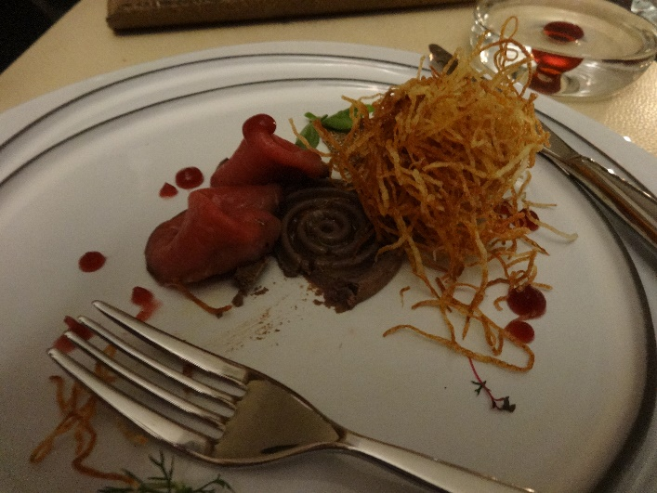

This is my starter, already partly disassembled: slices of beef carpaccio laid over a neat spiral of chicken liver pâté, surrounded by dots of port reduction and topped with a tangle of deep-fried potato shreds. Delicious.

Tomorrow, off to Venice by train.